

Department of Metallurgy & Materials

EAMPA User Mannual

by

Ben Palmer

Metallurgy & Materials, University of Birmingham

Metallurgy & Materials

College of Engineering & Physical Sciences

January 2015

Table of Contents

Table of Contents ii

Definitions and Abbreviations iii

1 Introduction 1

1.1 Advanced Materials for Fusion and Next Generation Reactors 1

1.1.1 Next Generation of Reactors 1

1.1.2 Super-Critical Water Reactors (SCWR) 1

2 References 3

Definitions and Abbreviations

Definitions

|  |  |
| --- | --- |
|  |  |
|  |  |
|  |  |
|  |  |
|  |  |
|  |  |
|  |  |
|  |  |

Abbreviations

|  |  |
| --- | --- |
| BCC | Body Centred Cubic |
| CPU | Central processing unit |
| DFT | Density Functional Theory |
| DPA | Displacements per atom – measurement of damage in a material |
| EPSRC | Engineering and Physical Science Research Council |
| FCC | Face Centred Cubic |
|  |  |
| GPU | Graphics Processing Unit |
| IGSCC | Inter Granular Stress Corrosion Cracking |
|  |  |
|  |  |
| MD | Molecular Dynamics |
| PBE | Perdew-Burke-Ernzerhof |
| PKA | Primary knock-on atom |
| RIP | Radiation Induced Precipitation |
| RIS | Radiation induced segregation |
|  |  |
|  |  |
| VPI | Vacancies per ion – measurement of damage caused by a particle beam |
| ZBL | Ziegler-Biersack-Littmark |
|  |  |
|  |  |
|  |  |

# Introduction

Embedded Atom Method (EAM) potentials are used to describe the energy, forces and stresses between a collection of atoms. This code analyses these potentials (calculates bulk properties of FCC and BCC crystals) and alters them to fit experimental bulk properties and DFT energy, force and stress data.

## Analysis

# Background

## EAM Potentials

|  |  |  |
| --- | --- | --- |
|  |  |  |

|  |  |  |
| --- | --- | --- |
|  |  |  |

## Interpolation Algorithms

### Lagrange Interpolation

In the EAMPA package, each component function of the EAM potential is expressed as tabulated data points rather than in an analytic form. Lagrange interpolation is used to calculate the value of the function between the data points.

An alternative would be to use linear algebra, and this would give the coefficients of the interpolated function. However, as we only need the value of the function f(x) at x, the Lagrange method is computationally faster.

For a set of data points:

$$D= \left\{\left(x_{0},y_{0}\right),\left(x_{1},y_{1}\right),\left(x_{2},y_{2}\right)…\left(x_{n},y_{n}\right)\right\}$$

The interpolated value Pn(x) is calculated as follows:

$$P_{n}\left(x\right)= y_{0}L_{0}\left(x\right)+y_{1}L_{1}\left(x\right)+…+y_{n}L_{n}\left(x\right)$$

$$L_{k}\left(x\right)= \frac{\left(x-x_{0}\right)…\left(x-x_{k-1}\right)\left(x-x_{k+1}\right)…\left(x-x_{n}\right)}{\left(x_{k}-x_{0}\right)…\left(x_{k}-x_{k-1}\right)\left(x_{k}-x_{k+1}\right)…\left(x_{k}-x_{n}\right)}$$

This is a more efficient way to interpolate between the points than solving a system of linear equations using matrix inversion, and a Fortran subroutine was developed to implement this as a part of this project.

### First Derivative (and Higher) Calculation using Lagrange Interpolation

The calculation of forces requires the derivatives of the functions that make up the EAM potentials. The Lagrange interpolation method can be modified to calculate these derivatives.

For a set of data points:

$$D= \left\{\left(x_{0},y_{0}\right),\left(x_{1},y_{1}\right),\left(x_{2},y_{2}\right)…\left(x_{n},y_{n}\right)\right\}$$

The interpolated value Pn(x) is calculated as follows:

$$P_{n}'\left(x\right)= y_{0}L_{0}'\left(x\right)+y_{1}L_{1}'\left(x\right)+…+y_{n}L_{n}'\left(x\right)$$

$$L_{k}\left(x\right)= \frac{1}{\left(x_{k}-x_{0}\right)…\left(x_{k}-x_{k-1}\right)\left(x_{k}-x_{k+1}\right)…\left(x_{k}-x_{n}\right)}M_{k}\left(x\right)$$

$$M_{k}\left(x\right)= \left(x-x_{0}\right)…\left(x-x_{k-1}\right)\left(x-x_{k+1}\right)…\left(x-x_{n}\right)$$

$$L_{k}'\left(x\right)= \frac{1}{\left(x_{k}-x_{0}\right)…\left(x_{k}-x_{k-1}\right)\left(x_{k}-x_{k+1}\right)…\left(x_{k}-x_{n}\right)}M_{k}'\left(x\right)$$

The product rule is used to solve Mk’(x), and an algorithm to do this was added to the Lagrange Interpolation Fortran subroutine mentioned in the previous section.

To interpolate and return higher order derivatives, the chosen method is to interpolate and return the first order derivatives from the initial set of data points at those data points. This results in the following set of data points:

$$D= \left\{\left(x_{0},y_{0},{y'}_{0}\right),\left(x_{1},y_{1},{y'}_{1}\right),\left(x_{2},y_{2},{y'}_{2}\right)…\left(x_{n},y_{n}\right)\right\}$$

The first derivative algorithm is then used to interpolate the (xn,y’n) points to give the second differential as the result of the interpolation.

## Equation of State

Four properties are calculated by fitting an equation of state to the volume-energy data points calculated from the EAM potential. Two equations of state were considered the Murnaghan and Birch-Murnaghan EoS.

Murnaghan:

|  |  |  |
| --- | --- | --- |
|  | $$U_{EAM}=\frac{1}{2}\sum_{i=1}^{N}{\sum_{j≠i}^{N}{V_{ij}\left(r_{ij}\right)+\sum_{i=1}^{N}{F\left[ρ_{i}\right]}}}$$ |  |

Birch-Murnaghan:

|  |  |  |
| --- | --- | --- |
|  | $$U_{EAM}=\frac{1}{2}\sum_{i=1}^{N}{\sum_{j≠i}^{N}{V_{ij}\left(r_{ij}\right)+\sum_{i=1}^{N}{F\left[ρ_{i}\right]}}}$$ |  |

The Birch-Murnaghan equation was selected as the Equation of State used in this code. A method of fitting the Murnaghan equation to volume-energy data points is outlined on the Carnegie Mellon University Chemistry website.

## Function Optimisation

# Installation

## Downloading/Preparing Source Files

This assumes the source code is stored in the home directory. Download the files from https://github.com/BenPalmer1983/eampa and place in a directory called ~/eampa.

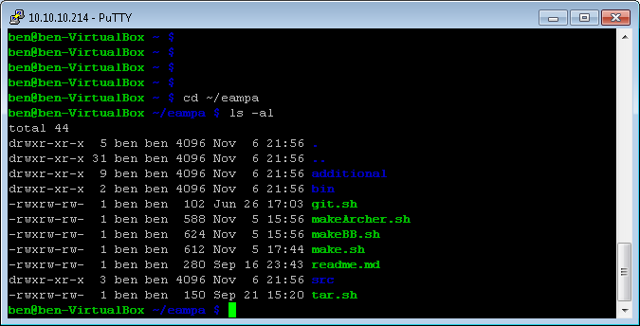

## Compiling Package

This package requires the GCC Fortran Compiler and OpenMPI libraries. To compile on a standard Linux (Debian or Redhat) system, execute the make.sh file:

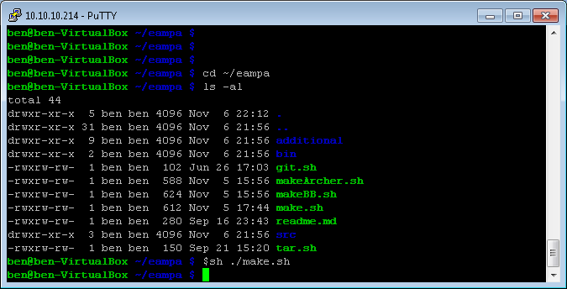

The compiled binary is output in the bin directory.

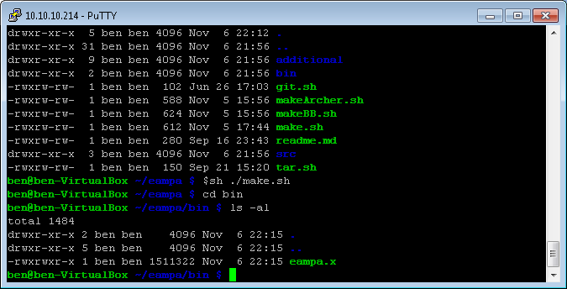

This can be executed from this directory. Alternatively a symlink may be created in the /usr/bin directory to the eampa.x executable, or the path ~/eampa/bin may be added to the user’s .bash_rc file. There are two more make files that should be run on Archer or BlueBEAR to compile (makeArcher.sh and makeBB.sh). Module files for Archer and BlueBEAR are already prepared in the ~/eampa/additional/module_files directory.

# Usage Instructions

## Introduction

These notes assume the working directory is in the home directory, and the .bash_rc file has been altered to run eampa.x directly from the command line, whatever the working directory.

## Basic Usage

An input file is required to run the program at the very least, even if the input file is empty.

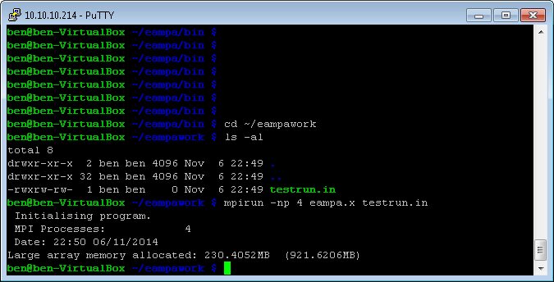

The input file contains all the information on what type of job the eampa.x package is running, the names of other files (if required) and so on.

## Input File

### Types of Job

The heading line to set the type of job is #RUNTYPE

|  |  |
| --- | --- |
| Job Keyword | Description of Job |
| EAMP | Prepare EAM potential file (converts from 2 column EAMPA format file, a LAMMPS file or DL_POLY file to an EAMPA file that also contains first and second derivatives of the functions). |
|  |  |
|  |  |
|  |  |
|  |  |
|  |  |
|  |  |

Example:

# Examples

http://www.iaea.org/About/Policy/GC/GC51/GC51InfDocuments/English/gc51inf-3-att7_en.pdf

